Effect of round-the-world surface seismic waves in the dynamics of repeated shocks of strong earthquakes - statistical properties
Zavyalov A.D., Zotov O.D., Guglielmi A.V., Lavrov I.P.
Schmidt Institute of Physics of the Earth RAS, Moscow, Russia, zavyalov@ifz.ru

Key Words: earthquake, a round-the-world surface seismic wave, aftershock, main shock.

The existence of the effect of the round-the-world surface seismic waves (“seismic echo”) in evolution of aftershock process was shown in the work on a broad evidence base, including hundreds of the main shocks and thousands of aftershocks. The effect is that the surface waves excited in the earthquake source by the main shock makes a complete revolution around the Earth and excites strong aftershock in the epicentral area of the main shock. The physical nature of the effect is that a critical concentration of wave energy in epicenter is created by converging surface waves under achieving of epicentral area. Effect of the first seismic echo is manifested most clearly. For the statistical analysis of the dynamics of the seismic events flow after strong earthquakes (main shocks), shocks), we selected several datasets from a long time series of the earthquakes contained in the global catalog USGS/NEIC for the period 1973-2014 and in the regional catalog of Northern California for the period 1968-2007. For data processing and efficiently detecting the effect of a seismic echo, we used an algorithm based on the well-known superposed epoch analysis, or synchronous detection method. In Fig. 1 shows the accumulated sequences of normalized magnitude of repeated shocks are shown. The effect of the seismic echo (black curve) is shown in comparison with the events in which the effect was absent (the gray curve) for the main shocks with magnitudes M ≥ 7.5 (Fig. 1a), 7 ≤ M < 7.5 (Fig. 1b), M ≥ 5.5 (Fig. 1c). Vertical dotted line in the pictures marks the time of the maximum effect of the first round-the-world echo. The detected phenomenon of the seismic echo can be used to increase the probability of a forecast of a strong aftershock in determining the scenario of seismic process in the epicentral zone of occurred strong earthquake.
This work was supported by the Russian Foundation for Basic Research, project # 18-05-00096.
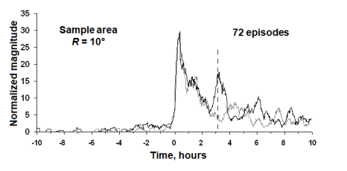 | 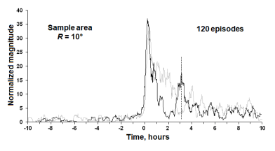 | 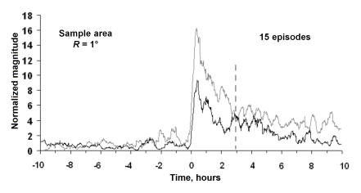
a | b | c
Fig. 1. Cumulative sequence of normalized magnitudes of repeated shocks for main shocks with magnitudes M ≥ 7.5 (a); 7 ≤ М < 7.5 (b) catalog USGS/NEIC; М ≥ 5.5 (c) Northern California catalog. Identified effect of seismic echo (black line) is shown against events in which effect is absent (gray line). Vertical dashed line marks time of maximum in effect of first round-the-world seismic echo.

References:
Zotov O.D., Zavyalov A.D., Guglielmi A.V., Lavrov I.P. On the Possible Effect of Round-the-World Surface Seismic Waves in the Dynamics of Repeated Shocks after Strong Earthquakes // Izvestiya, Physics of the Solid Earth, 2018, Vol. 54, No. 1, pp. 178-191.

