Title:
Nitroxide-mediated copolymerization of macromonomers based on polyethylene oxide
Authors & affiliations:
Please do not include Personal Data (email address, postal address, etc.) in this field. Include only author names & affiliations
Rumyantsev S. A., Zaremski M. Yu., Odintsova V. V., Melik-Nubarov N.S.
Lomonosov Moscow State University, Faculty of Chemistry, Department of Polymers
Abstract: (Your abstract must use Normal style and must fit in this box. Your abstract should be no longer than 300 words. The box will ‘expand’ over 2 pages as you add text/diagrams into it.)
Preparation of Your Abstract
1. The title should be as brief as possible but long enough to indicate clearly the nature of the study. Capitalise the first letter of the first word ONLY (place names excluded). No full stop at the end.
2. Abstracts should state briefly and clearly the purpose, methods, results and conclusions of the work.
Introduction: Clearly state the purpose of the abstract
Methods: Describe your selection of observations or experimental subjects clearly
Results: Present your results in a logical sequence in text, tables and illustrations
Discussion: Emphasize new and important aspects of the study and conclusions that are drawn from them
The features of living nitroxide-mediated copolymerization with the participation of macromonomers are weekly studied , so this task is still important. Here, we present the results of the study of the kinetics and mechanism of the formation of amphiphilic copolymers of MMA with PEG-based macromonomers in comparison with MMA homo-polymerization. For this purposes the new alkoxyamine initiator were applied.
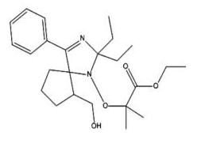
A2
For the controlled synthesis of copolymers of MMA with PEG, methacrylate derivatives of PEG (PEGMA) were synthesized and characterized.
The features of nitroxide-mediated copolymerization of MMA with PEGMA1900 were studied by means of ESR and isothermal calorimetry. The addition of 10 wt.% PEGMA to MMA does not affect either the concentration of free nitroxyl or the rate of polymerization. A pronounced Fischer effect (strong and fast increase in free nitroxide concentration) was observed during the copolymerization (figures 1, 2).
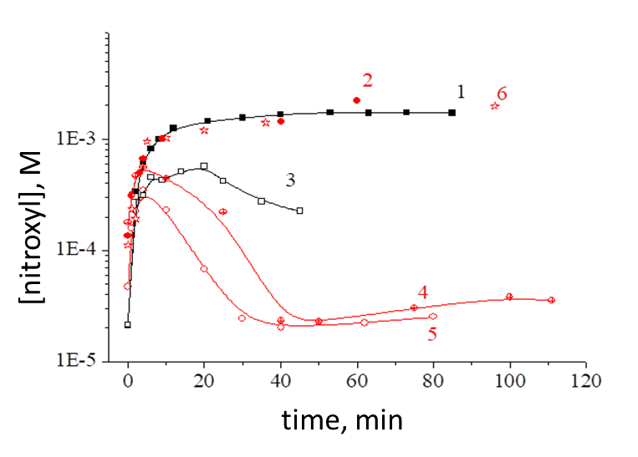
Figure 1. The change in nitroxyl concentration in the course of the polymerization of MMA (1,3) and the copolymerization of MMA – PEGMA (2.4–6), initiated by A2 at 80 ° C. Curves 3, 4, and 5 correspond to systems with the addition of AIBN. [A2] = 0.01 M (1-4) and 0.005M (5); [AIBN] = 0,01M (3,4) and 0,005 M (5). Curve 6 responds to the system with the addition of 0.005 M H₂SO₄.
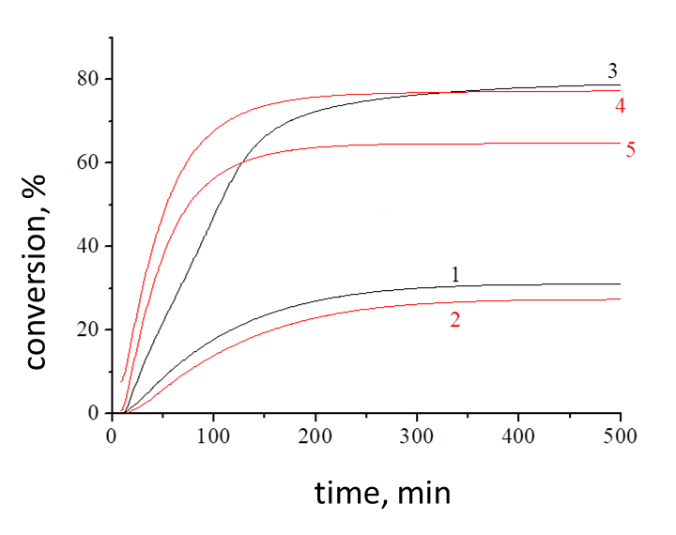
Figure 2. Integral kinetic curves for the polymerization of MMA (1,3) and the copolymerization of MMA – PEGMA (2,4,5) under the action of nitroxyl at 80 °C. Designation, see figure 1.
To increase the copolymer yield, we added AIBN, which provides the system with free radicals that bind nitroxyl. The introduction of one equivalent of AIBN reduces the stationary concentration of nitroxyl by an order of magnitude in the case of homo- and copolymerization. A sharp decrease in the concentration of free nitroxyl leads to an increase in the rate of polymerization by a factor of 2-3. The addition of AIBN to the homopolymerization system leads to the appearance of a weak gel effect, while in the copolymerization this effect is absent.
Recently, it has been proposed that sulfuric acid can be used as an additive to drastically reduce the background nitroxyl concentration and increase the polymerization rate of MMA, without disturbing the living polymerization mechanism. According to our data, sulfuric acid repeatedly increases the rate of polymerization of MMA, initiated by AIBN in the presence of TEMPO.
A series of amphiphilic comb-shaped copolymers was synthesized with Mw in the range of 8000–15000 with M_{w}/M_{n} of 1.3. The NMR method showed that they contain 0.56 mol.% PEGMA. A system was developed for purification of copolymers from unreacted residual macromonomer. Further studies will be conducted on micelle formation and cytotoxicity of these copolymers.

The work was done with financial aid granted by RFFI (grant №18-03-00707)
The authors are grateful to prof. Chernikova E.V. for GPC and PhD Budynina E.M. for NMR-analysis.

