Theoretical investigation of the structure and photophysics of homological series of bis(aryliden)cycloalkanones

Starostin R.O., Freidzon A.Ya., Gromov S.P.

Photochemistry Center, RAS, FSRC “Crystallography and Photonics”, RAS, 119421, Moscow, Novatorov str. 7A-1
e-mail: star.roman-96@yandex.ru
α,α’-Bisarylidene derivatives of cyclic ketones (dienones of cycloalkanone series) are famous for their photochromic and fluorescent properties, which make them applicable as fluorescent probes and photosensitizers in biology [1-2].
Here, we have found theoretically the stable structures of dienons with various electron donating groups in the ground and lower excited states. Main regularities of transitions between the states and excitation relaxation pathways were investigated. The calculated data were used to explain the results of photophysical experiments [3-4].

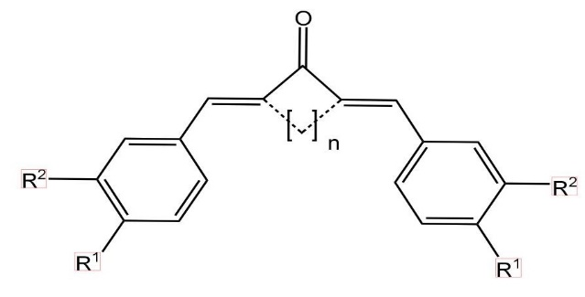 | R¹ = H, OMe, SMe, NMe₂, NEt₂; R² = H, OMe; n = 1-3

Quantum chemical calculations were performed using DFT and TDDFT methods with the PBE0 functional in the 6-31+G(d,p) basis in the Firefly software. Solvent effect was taken into consideration using continuum model.
The influence of conformation, central cycle size and substituent type on the position of absorption and emission maxima in the calculated spectra of substances under question were analyzed. The processes of light absorption, fluorescence and nonradiative relaxation by internal rotation around exocyclic double bonds were considered. The calculation results were in good accordance with the experiment [3-4] and made it possible to explain observed patterns in the spectral and photophysical properties of molecules.

This work was supported by the Russian Science Foundation (grant No. 22-13-00064).

References
[1] Doroshenko, A.O.; Sychevskaya, L.B.; Grygorovych, A.V.; Pivovarenko, V.G. J. Fluorescence, 2002, 12, 455.
[2] Lin, Y.; Jiang, X-F.; Duan, X.; Zeng, F.; Wu, B.; Wu, S. ACS Med. Chem. Lett., 2018, 9, 23.
[3] Gutrov, V.N.; Zakharova, G.V.; Fomina, M.V.; Starostin, R.O.; Nuriev, V.N.; Gromov, S.P.; Chibisov, A.K. High Energy Chemistry, 2020, 54, 303.
[4] Vatsadze, S.Z.; Gavrilova, G.V.; Zyuz´kevich, F.S.; Nuriev, V.N.; Krut´ko, D.P.; Moiseeva, A.A.; Shumyantsev, A.V.; Vedernikov, A.I.; Churakov, A.V.; Kuz´mina, L.G.; Howard, J.A.K.; Gromov, S. P. Russ. Chem. Bull., 2016, 65, 1761.

