**ON THE STRAPDOWN INS ACCURACY ASSESSMENT CRITERIA UPON FLIGHT TEST RESULTS**

**N.B. Vavilova[1], A.A. Golovan[2], I.A. Papusha[3], N.A. Parusnikov[4]**

Lomonosov Moscow State University, Moscow, Russia, e-mail: aagolovan@yandex.ru

**O.A. Zorina[5], E.A. Izmailov[6], S.E. Kuhtevich[7], A.V. Fomichev[8]**

PAO "MIEA", Moscow, Russia, e-mail: [aomiea@aviapribor.ru](mailto:aomiea@aviapribor.ru)

**Abstract**

**Keywords:** SINS, navigation solution accuracy estimation

*The report provides test results of checking the hypothesis on the Gaussian distribution of errors in the position determinations defined during numerous flights within one-hour time sample for SINS installed on board high-maneuverable objects. The problem under consideration concerns the correctness in the employment of quality evaluation criteria for SINS navigation solution based on the hypothesis on the Gaussian distribution of errors in the position determinations within time samples. A new alternative method for SINS navigation solution accuracy estimation is proposed.*

**Introduction**

In making up the conclusion on the accuracy of the SINS navigation solution issued to a user by SINS the stated below procedure is common. Using results of integrated processing data gained from the SINS and an external reference template, the estimates of errors in navigation parameters are plotted, the latter being compared with the tolerable limits. Limit values can be constant or may vary with the lapse of time. For example, error tolerance limits in positioning and heading remain constant within the first hour and then grow linearly with the time after the first hour of the flight. Error tolerance values in velocity, bank and pitch angles tolerance are considered to be constant during the entire flight.

To estimate the probability that navigation solutions lie within the tolerable limits for a large amount of flights various statistical methods of the recorded data processing are used. The error estimation processing based on time samples isconsidered to be quite common, for which such statistical characteristics as the average М-number, root-mean-square deviation σ, circular probable deviation, etc. are calculated. Further work with these notions usually implies that error distribution is in conformity with the normal (Gaussian) law and on the basis of this assumption the tolerability estimations are made. Thus, the comparison of |M|+2σ value with the tolerance limit value is used for the judgment that the error is tolerable with 0.95 probability. However, if the error distribution law differs from the normal one, similar probabilistic inference might be incorrect.

**On the method of the SINS accuracy estimation upon flight test results**

Let us consider as an example (Fig 1) one sample from 66 SINS latitude errors values stored within one hour of flight, each of them lying within the tolerance limits (1.85 km), and the |M|+2σ = 1.94km value appearing to be intolerable. Such a not quite adequate situation, when a series of completely tolerable navigation solutions can be rejected because of the only |M|+2σ value, may occur if the navigation parameter error distribution law does not correspond in real life to the normal one.

For further reasoning, let us consider the SINS error equation system [1], given in the matrix form

$\dot{x}\left(t\right)=A\left(t\right)x+q$,

where *х –* system status vector, *q –* sensor error noise components. The property of importance for the system is that the system matrix depends significantly on the motion trajectory. Therefore, while considering SINS errors inherent in different trajectories, we obtain a set of linear systems with different matrices:

Trajectory 1: ${\dot{x}}_{1}\left(t\right)=A_{1}\left(t\right)x_{1}+q_{1}$

Trajectory 2: ${\dot{x}}_{2}\left(t\right)=A_{2}\left(t\right)x_{2}+q_{2}$ (1)

……………………………………….

Trajectory n: ${\dot{x}}_{n}\left(t\right)=A_{n}\left(t\right)x_{n}+q_{n}$

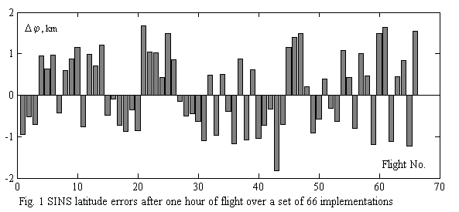

It is known that random linear system solution is expressed via initial conditions and the transition matrix; therefore *x*i*(t)* solutions for a set of systems (1) have the following form:

$x_{1}\left(t\right)=Φ_{1}\left(t, t_{0}\right)x_{1}^{0}+\int_{t_{0}}^{t}{Φ_{1}\left(t, τ\right)q_{1}\left(τ\right)dτ, }$

…………………………………………… (2)

$$x_{n}\left(t\right)=Φ_{n}\left(t, t_{0}\right)x_{n}^{0}+\int_{t_{0}}^{t}{Φ_{n}\left(t, τ\right)q_{n}\left(τ\right)dτ, }$$

where *Φi* (*t, to*) – transition matrix for *i* - trajectory, *xio*– phase vector initial value for this trajectory. The formulae (2) imply that even in case if phase vector *xio, …, xno* initial values are distributed according to the normal law (which appears reasonable, for example, for the phase vector part, composed of instrument errors), and system noises are white, then the equations (2) convert this very sample into the value population with more complex and a priory not obvious distribution law. Moreover, the normal distribution will occur only with transition matrix equality in the equations (2). It also should be noted, that transition matrices in the equations (2) can't be obtained analytically, even if SINS is motionless relative to the Earth. It makes the study of the navigation error distribution law more difficult.

The arguments above allow making doubtful the adequacy of SINS navigation error estimations, obtained using parameters of the normal distribution law for those errors.

Since the estimation approaches to the assessment, based on the hypothesis of random error normal distribution law are very common, below is given the study of conformity of flight tests and simulation data with the normal law using mathematical statistics methods and guidelines [2].

**Test results of Gaussian hypothesis of SINS positioning errors per one flight hour**

The results given below were received while analyzing data of flight tests of SINS installed on high-maneuverable objects, in all 170 flights in 2015-2016. The study objective was checking of the Gaussian hypothesis for latitude and longitude SINS errors per one hour flight time sample (Fig. 2, 3). For checking the hypothesis were employed fitting criteria implemented in one of application software packages designed for technical computing: Pearson criterion - GOST recommended [2], Kolmogorov-Smirnov criterion [3] and Lilliefors criterion [4].

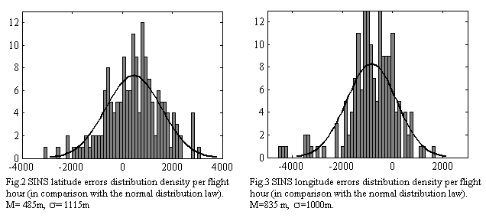

Using the above criteria the test was carried out to show that distribution of a general set of random variable values does not contradict to the normal law for  0.05 critical significance level (it is treated as a probability of incorrect rejection of a Gaussian hypothesis whereas it is true) [3]. The Gaussian hypothesis on SINS distribution of latitude and a longitude errors per one hour flight time sample within 170 flight data was not proved by any of the criteria. Table 1 provides  significance level values, corresponding to a sample value of test statistics for the applied fitting criteria.

Table 1. *a*-significance level shown by fitting criteria

|  |  |  |  |
| --- | --- | --- | --- |
|  | Pearson Criterion | Kolmogorov-Smirnov Criterion | Lilliefors Criterion |
| Latitude errors | 0.0003 | 0.05 | 0.003 |
| Longitude errors | 0.0005 | 0.038 | 0.001 |

Based upon these data, it may be concluded that SINS positioning errors are unlikely distributed according to the normal law, and in particular by Pearson criterion.

**Visual comparison of distribution functions**

Checking of the Gaussian hypothesis on normal error distribution in latitude and longitude definition per one flight hour can be conducted by the visual comparison of histograms *(geometrical representation of distribution density empirical function)* with the probability density plot for the normal law (Fig 2,3). It is also possible to compare function curves for the distribution of SINS latitude and longitude errors per one flight hour with the distribution function for the normal law with the identical characteristics (M, σ), which is shown in Fig. 4 and 5.

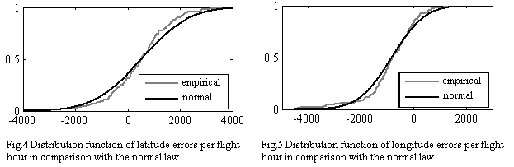

Thus, it is rather difficult to confirm or disprove visually a Gaussian hypothesis on the distribution of positioning errors after one hour of flight.

**Hints on the dependence of Gaussian hypothesis check results against the sample volume**

It should be noted that the validity of the conclusion about the distribution law, received on the basis of fitting criterion, depends essentially on the sample volume. Below are given test results for fitting criteria implemented in one of application software packages used for technical calculations: Pearson criterion, Kolmogorov-Smirnov criterion and Lilliefors criterion are given below.

For the experiment were generated random number samples of different volume with the specified characteristics of M = 0, σ=1 distributed according to *the uniform law and Laplace* *distribution* (Fig. 6, 7). The hypothesis that exponential population distribution does not contradict *the standard normal law* for the critical significance level ά = 0.05 was checked by means of Pearson, Kolmogorov-Smirnov, Lilliefors criteria.

Table 2 shows values for sample volumes of random numbers at which the fitting criteria considered consistently differentiate various distribution laws, i.e. reject the accepted hypothesis about the sample distribution normality, distributed in real life according to some other law.

Table 2. Sample volumes of random numbers at which the fitting criteria considered invariably distinguish uniform and Laplace distribution from the normal distribution law

|  |  |  |  |
| --- | --- | --- | --- |
|  | Pearson Criterion | Kolmogorov-Smirnov Criterion | Lilliefors Criterion |
| Uniform | 310 | 400 | 180 |
| Laplace | 340 | 430 | 220 |

According to data in Table 2 it may be concluded that the sample of one-two hundred flights can be insufficient for the judgment about the distribution law.

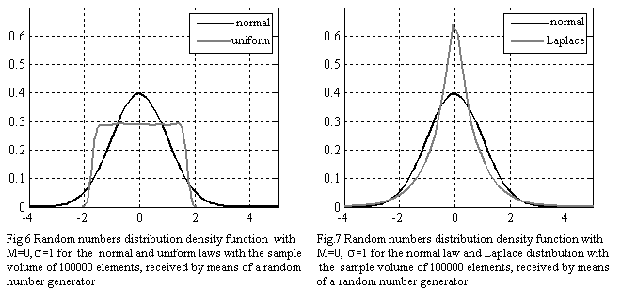

**Conclusions**

As it follows from the above results, the question about distribution laws for SINS navigation errors appears to be rather complicated. It is conditioned by the essential dependence of the error distribution law upon flight trajectories, the impossibility of analytical calculation of transition matrices for error equations and the necessity to store a huge sample of experimental data for objective statistic estimations. However, in practice, are common the estimation criteria based on the hypothesis on the normal distribution law, which has no natural grounds for SINS navigation errors. More objective are estimation methods for determining errors within the tolerable limit, which do not depend on the distribution law.

To estimate the error of the SINS navigation parameter, can be used the ratio of the sum of the time intervals (for all flights) during which the parameter is in the tolerable limit to the total duration of all flights. The advantages of such a method are as follows:

* obvious referencing of the criterion to the time when the error goes beyond the limits of tolerance which is clearly visible on error-time dependence curves;
* the criterion does not rely on a priori hypotheses on navigation error distribution laws;
* the method is tolerant to short-term faults in error estimations.

Other methods, which also do not depend on the distribution law, include an estimation of probability of getting into the limits of tolerance with the help of the Bernoulli scheme or using circular error probability.

**References**

1. **Golovan A.A., Parusnikov N.A.** Matematicheskie osnovy navigatsionnyh system.(Mathematical background of navigation systems. Part I. Mathematical models of inertial navigation). 3rd Ed., revised and corrected, Moscow: MAKS Press, 2011.
2. **GOST P 8.736-2011** Izmereniya pryamyie mnogokratnyie. Metody obrabotki rezultatov izmereniy. Osnovhyie polozheniya.(Multiple direct measurements. Methods of measurement results processing. Fundamental principles), Moscow: Standartinform, 2013
3. **Bocharov P.P., Pechinkin A.V.** Teoriya veroyatnostey. Matematicheskaya statistika. (Probability Theory. Mathematical Statistics). Moscow: Gardarika, 1998, 328 p.

1. PhD in Phys and Math, [Leading researcher](http://www.lingvo.ua/ru/Search/Translate/GlossaryItemExtraInfo?text=%d0%b2%d0%b5%d0%b4%d1%83%d1%89%d0%b8%d0%b9%20%d0%bd%d0%b0%d1%83%d1%87%d0%bd%d1%8b%d0%b9%20%d1%81%d0%be%d1%82%d1%80%d1%83%d0%b4%d0%bd%d0%b8%d0%ba&translation=leading%20researcher&srcLang=ru&destLang=en)
2. D.Cs. in Phys and Math, Head of laboratory
3. PhD in Phys and Math, Senior [researcher](http://www.lingvo.ua/ru/Search/Translate/GlossaryItemExtraInfo?text=%d0%b2%d0%b5%d0%b4%d1%83%d1%89%d0%b8%d0%b9%20%d0%bd%d0%b0%d1%83%d1%87%d0%bd%d1%8b%d0%b9%20%d1%81%d0%be%d1%82%d1%80%d1%83%d0%b4%d0%bd%d0%b8%d0%ba&translation=leading%20researcher&srcLang=ru&destLang=en)
4. D.Cs. in Phys and Math, Prof.
5. PhD in Phys and Math, Head of Section
6. D.Cs. in Eng., Deputy thematic Branch Head - Deputy Сhief Designer
7. PhD in Phys and Math, Head of Department
8. PhD in Phys and Math, Deputy thematic Branch Head - Deputy Сhief Designer